GUIDESPEND AI
USER GUIDE

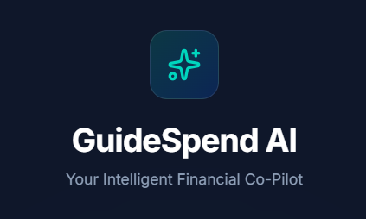

Team 8

CS 451R, Spring 2026

Team Members:

Madhavananda Sangaraju

Siva Nikitha Mandla

Mitul Neerubai

Sai Praneeth Pothuri

Table of Contents
Team 8 1
1. Introduction 3
2. Getting Started 3
2.1 System Requirement Details 3
2.2 Quick Start 3
3. Home Page: 4
4. Creating an Account 4
5. Logging In 5
6. Navigating the Dashboard 6
6.1 Summary Cards 6
6.2 Connecting a Bank Account 6
6.3 Recurring Payments 7
6.4 Cash Flow Forecast 8
6.5 Analytics Charts 8
6.6 Transactions Table 9
6.7 Using the AI Financial Chatbot 9
To use the AI chatbot: 10
6.8 Viewing Your Profile and Settings 11
6.9 Logging Out 12
7. Glossary 13
7.1 Dashboard 13
7.2 JWT (JSON Web Token) 13
7.3 Plaid and Sandbox Mode 13
7.4 Gemini API 13
7.5 Transaction 13
4.6 SSL (Secure Sockets Layer) 13

Introduction
Managing personal finances can be overwhelming when your banking information is spread across multiple apps and statements. GuideSpend AI brings everything together in one intelligent, easy-to-use dashboard.
With GuideSpend AI you can:
- Connect your real bank accounts securely using the Plaid API in sandbox mode
- Automatically sync and view all your transactions in one place
- Visualize your spending patterns with interactive pie charts and bar charts
- View your account balances across all linked institutions at a glance
- Ask financial questions and get personalized AI-powered answers through the built-in chatbot
- Access all your financial information from a single dashboard - no navigation between multiple pages
GuideSpend AI is a web application that runs in any modern browser. No installation is required. Your data is protected using industry-standard security including encrypted passwords, secure tokens, and SSL-protected database connections.

Getting Started
To use GuideSpend AI, you need:

2.1 System Requirement Details
- Web Browser : Google Chrome (recommended), Firefox, or Microsoft Edge - latest version
- Internet Connection: Active internet connection required for bank syncing and AI chatbot
- Account: A registered GuideSpend AI account (free to create)

2.2 Quick Start
- To get up and running with GuideSpend AI in minutes and open your web browser and navigate to the GuideSpend AI application URL
- Click 'Create one' on the login page to register a new account; Enter your name, email address, and a password (minimum 6 characters)
- Click Register - you will be automatically logged in and taken to your dashboard
- Click 'Connect Bank Account' to link your first bank account and your transactions and balance will appear on the dashboard automatically

Home Page:
This is how the home page looks like once user navigates the GuideSpend AI application in their browser.
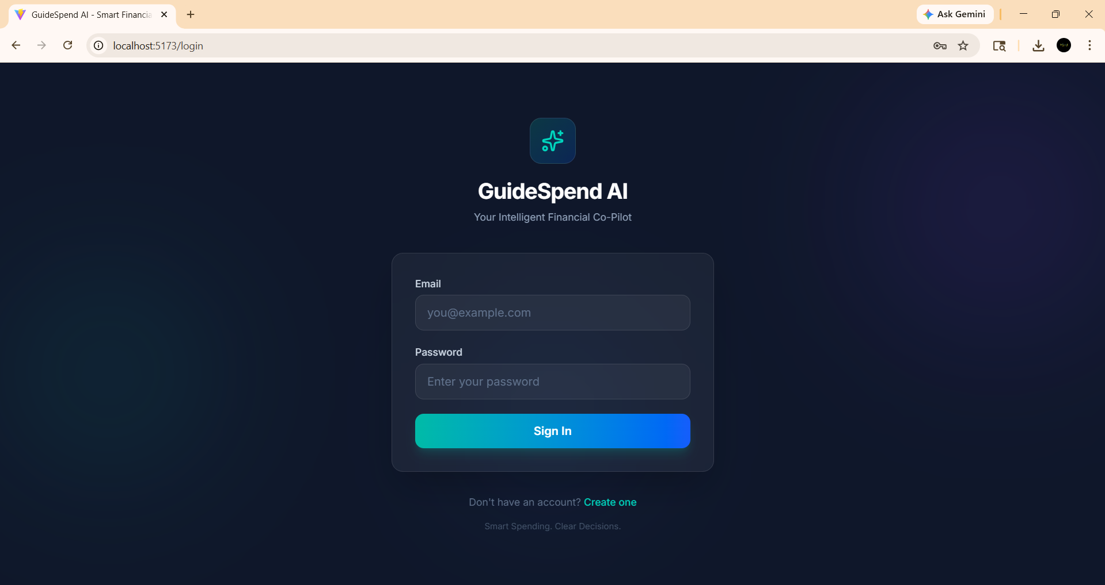

Creating an Account
To use GuideSpend AI you need to create a free account. Your account stores your linked bank connections and transaction history securely.
To create a new account:
- On the login page, click the 'Create one' link below the Sign In button
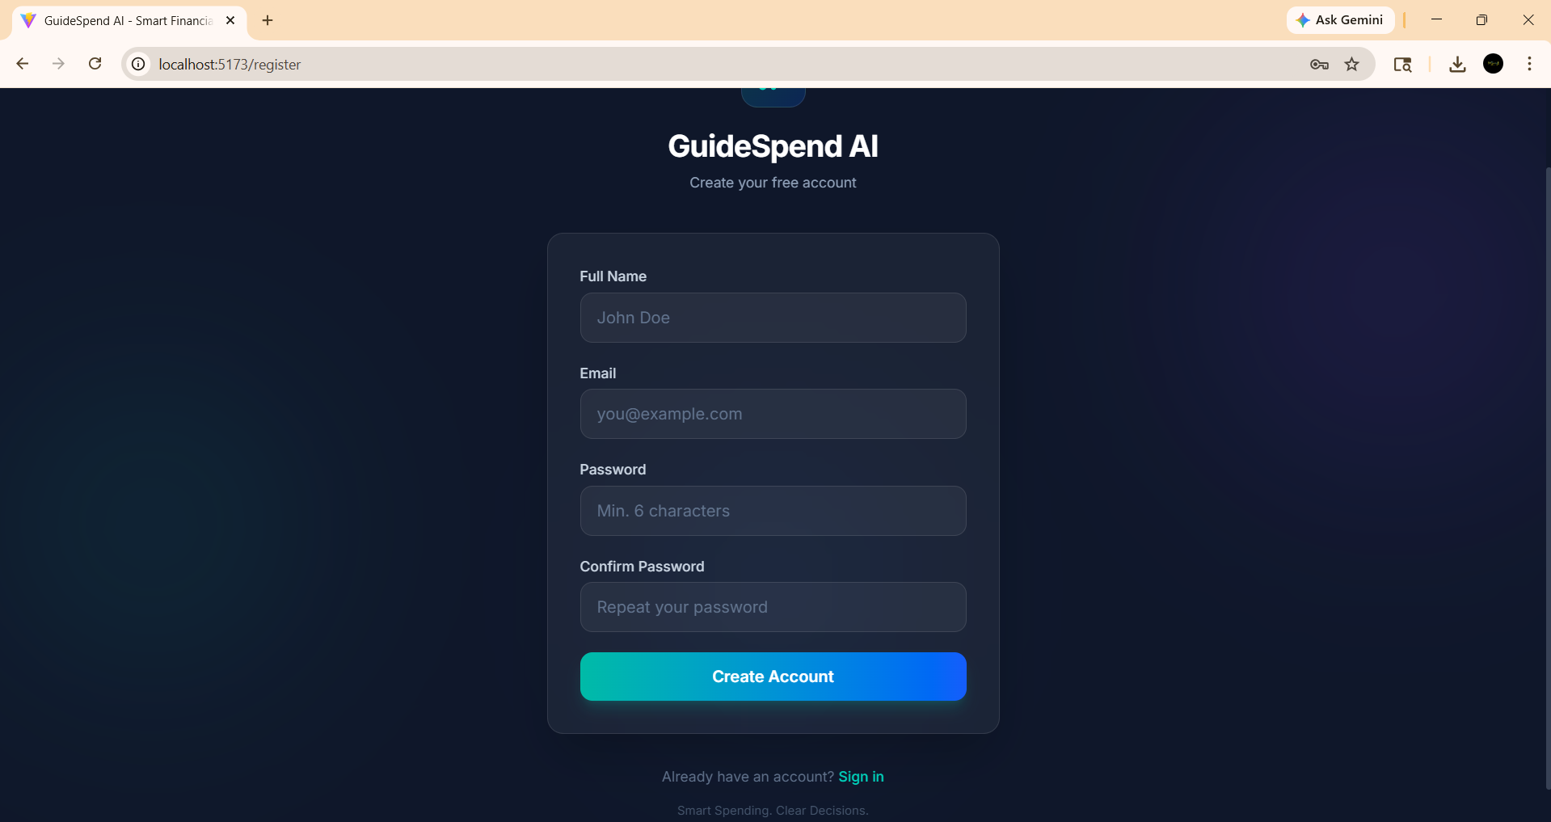
On the Register page, enter the following information:
- Full Name - your name as you want it displayed
- Email Address - a valid email address (this will be your username)
- Password - minimum 6 characters
- Confirm Password - re-enter the same password
- Click the Register button
- If your passwords do not match or are too short, an error message will appear - correct the issue and try again
- Once registered successfully, you will be automatically logged in and redirected to your dashboard

Logging In
Once you login, this is how the UI looks like:
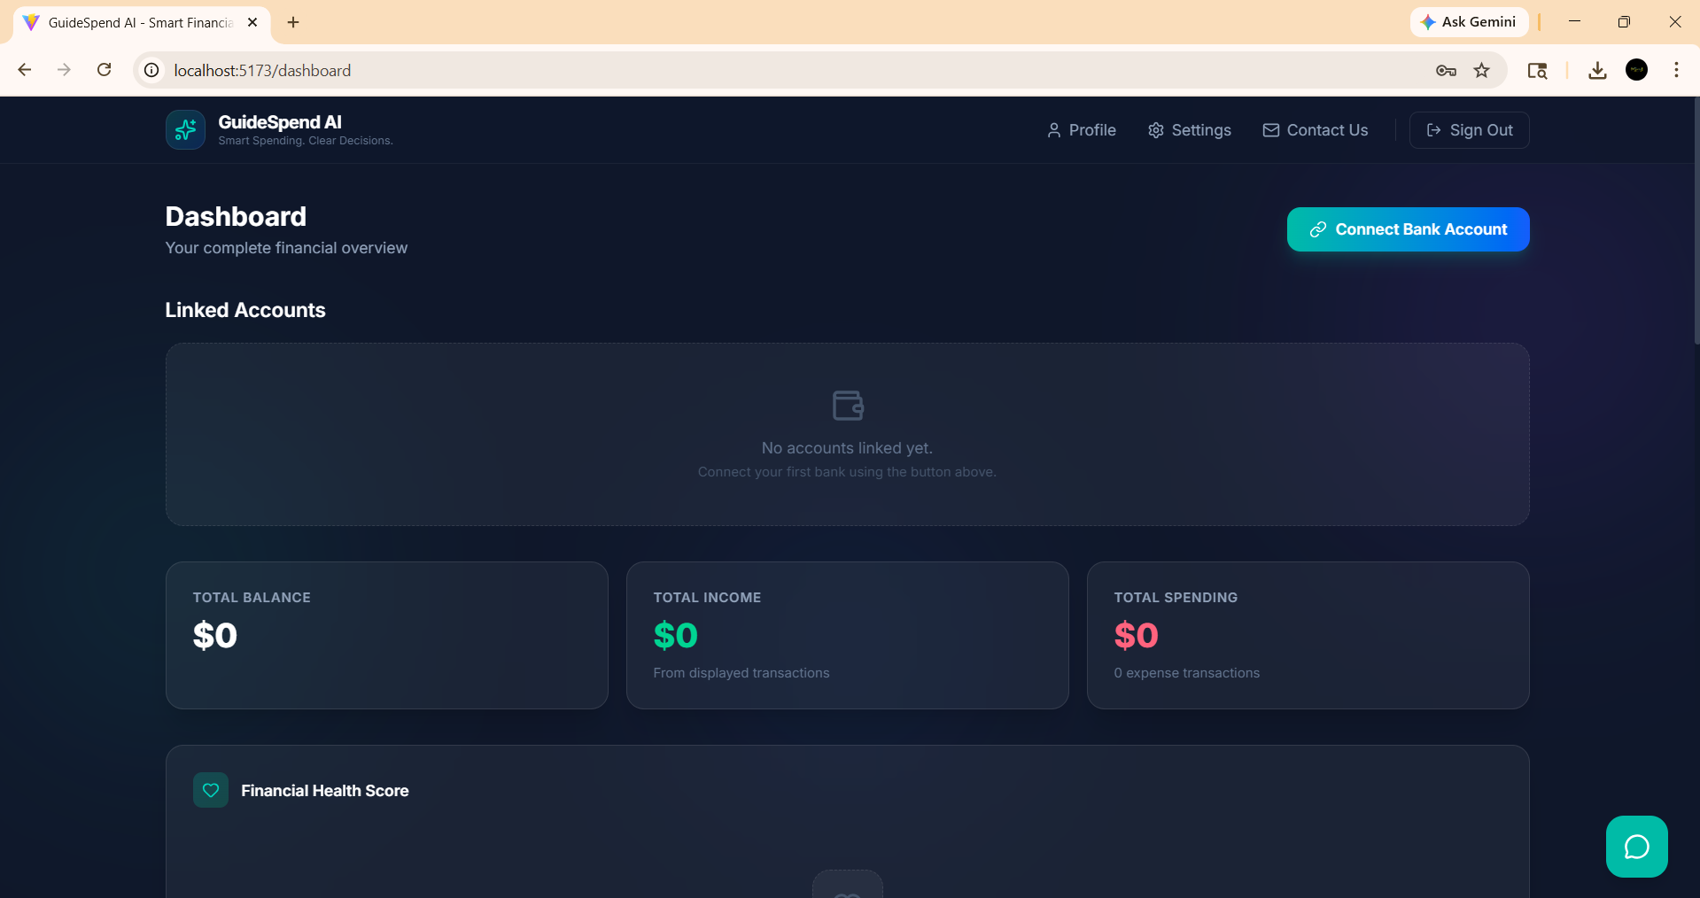

Navigating the Dashboard

6.1 Summary Cards
At the top of the dashboard you will see three summary cards along with all the linked accounts:
- Total Balance - the sum of all balances across all your linked bank accounts
- Total Income - the total of all positive (income) transactions
- Total Spending - the total of all expense transactions
- Click on individual bank accounts to get their specific analytics
These cards update automatically whenever new transactions are synced from your bank.

6.2 Connecting a Bank Account
GuideSpend AI uses Plaid - a secure, industry-standard banking API - to connect your bank account and sync your transactions. Your actual bank credentials are never stored by GuideSpend AI.

Note: GuideSpend AI currently uses Plaid in sandbox mode. Use the Plaid test credentials provided below to connect a simulated bank account.
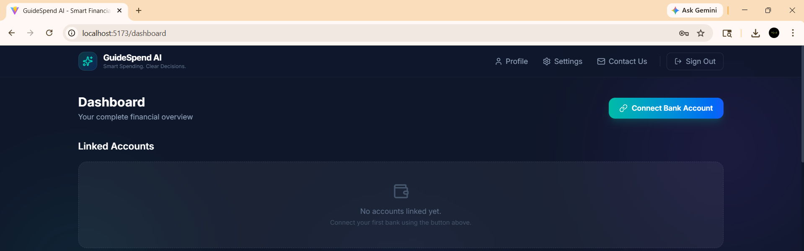

To connect a bank account:
- From your dashboard, click the 'Connect Bank Account' button
- The Plaid Link window will open as an overlay and then follow the plaid flow to complete the process.
Once you have the bank connected, this is how the updated dashboard looks:
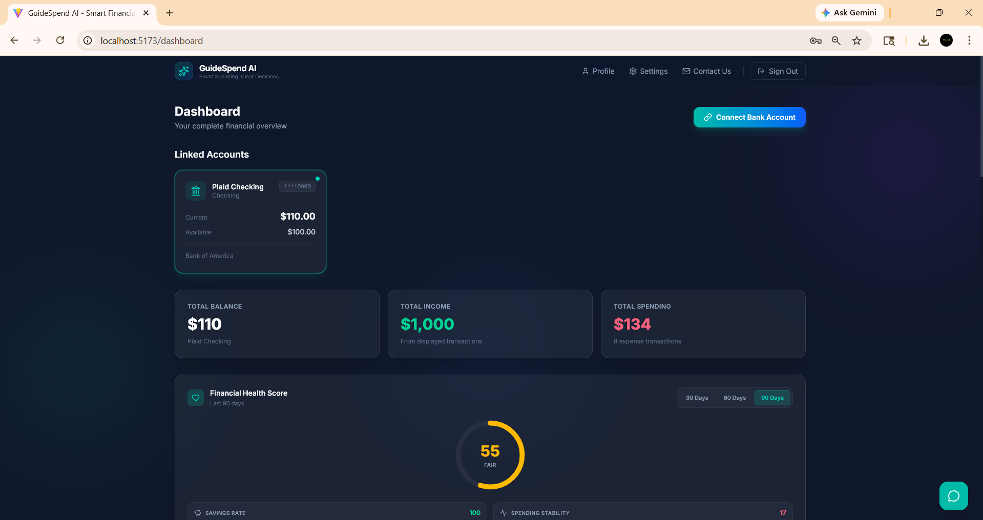
The balances, total income, total spending and the financial health score are all updated automatically.

6.3 Recurring Payments
The Recurring Payments section automatically detects your subscription and recurring charges based on your transaction history. It displays each detected subscription with the merchant name, frequency (Monthly, Biweekly), average charge amount, and a confidence percentage indicating how certain the system is that it is a recurring payment. The total estimated monthly cost of all detected subscriptions is shown at the top. Click Rescan to refresh and detect any new recurring payments.

6.4 Cash Flow Forecast
The Cash Flow Forecast section projects your account balance over the next 7, 14, or 30 days based on your recent spending patterns. It shows:
- Overdraft Risk - indicates whether your balance is at risk of dropping below zero (Low, Medium, or High Risk)
- Projected Balance - your estimated balance at the end of the selected period
- Lowest Balance - the lowest your balance is expected to drop and on which date
- Daily Averages - your average daily spend and income
- Upcoming Subscriptions - any recurring charges expected within the forecast period

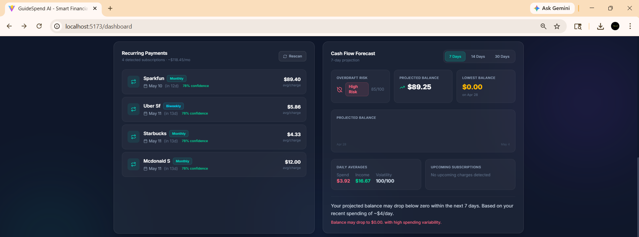

6.5 Analytics Charts
The Analytics section displays two interactive charts:
- Spending by Category (Pie Chart) - shows your top spending categories as a donut chart. Hover over each section to see the category name and amount.
- Monthly Spending Trend (Bar Chart) - shows your spending over the last 6 months. Each bar represents one month's total spending.

6.6 Transactions Table
The transactions table at the bottom of the dashboard lists all your transactions ordered by date (most recent first). Each row shows:
- Date - the date the transaction occurred
- Description - the merchant or transaction name
- Account - the bank account associated with the transaction
- Category - the spending category (e.g., Food and Drink, Transportation)
- Amount - positive amounts are income (shown in green), negative amounts are expenses
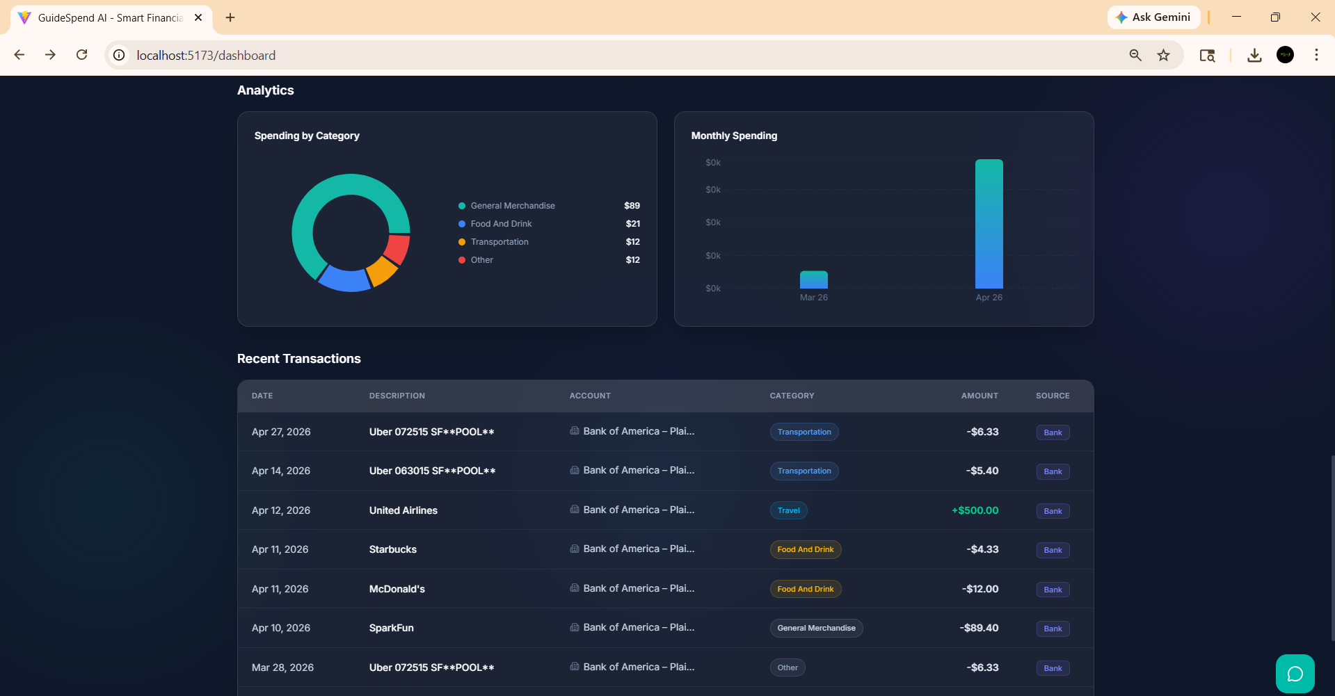

6.7 Using the AI Financial Chatbot
GuideSpend AI includes an AI-powered financial assistant that can answer questions about your spending and provide personalized financial insights. The chatbot is powered by Google Gemini and uses your actual transaction data to give accurate, relevant answers.

There is a floating icon at the bottom right of the screen. Click it to open the chatbot and ask financial questions.

To use the AI chatbot:
- Click the floating chatbot icon at the bottom right of the dashboard
- Type your financial question in the input field
- Click Send or press Enter on your keyboard
- Wait a few seconds for the AI to analyze your transactions and generate a response
- The answer will appear in the chat area above the input field
Example questions you can ask:
- 'How much did I spend on food this month?'
- 'What is my total spending for the last 30 days?'
- 'Which category did I spend the most on?'
- 'How does my spending this month compare to last month?'
- 'What are my most frequent transactions?'
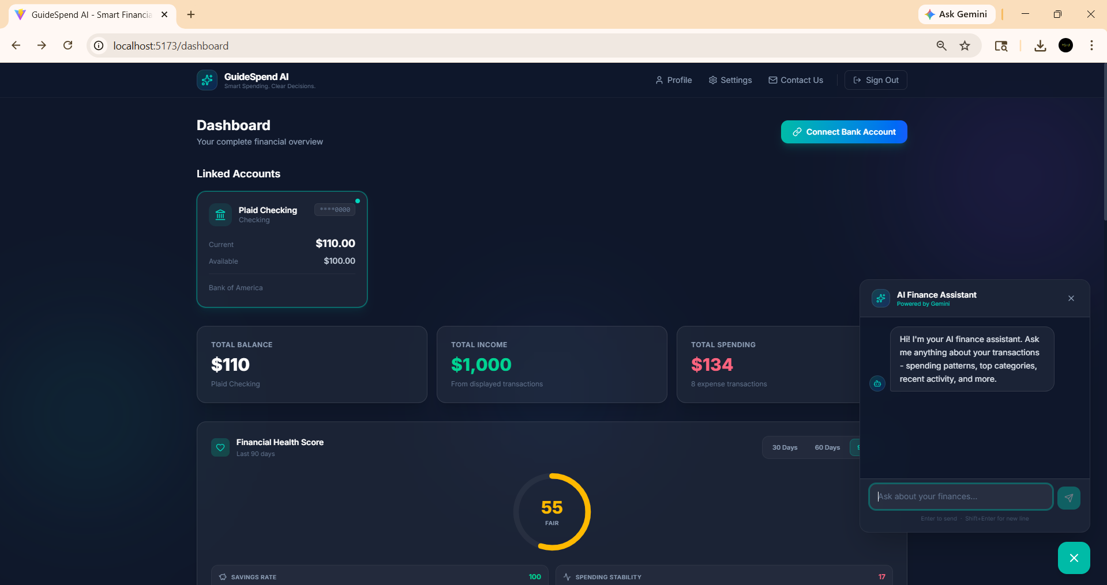
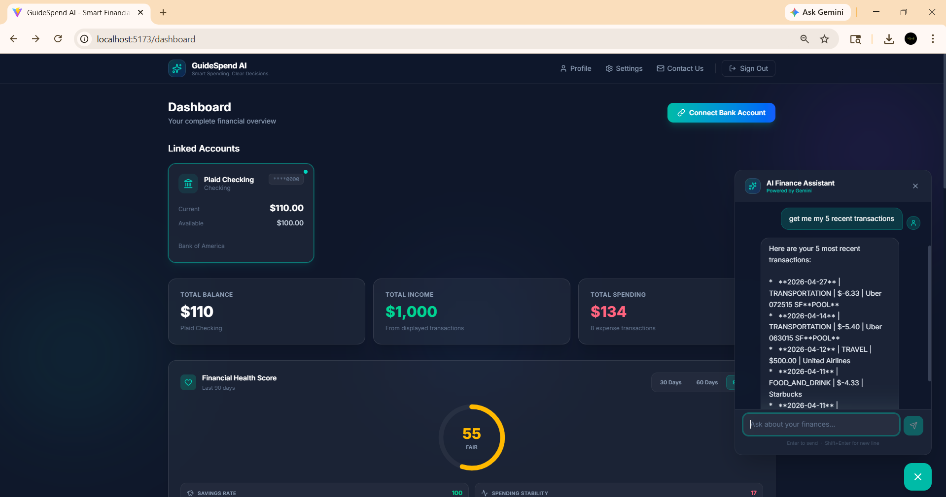

6.8 Viewing Your Profile and Settings
To view your account profile information:
- From the dashboard, locate the Profile or Settings section
- Your profile displays your registered email address and username
- Password is not displayed for security reasons
The Settings page also allows users to change the display language so that everyone can use GuideSpend AI in their preferred language.
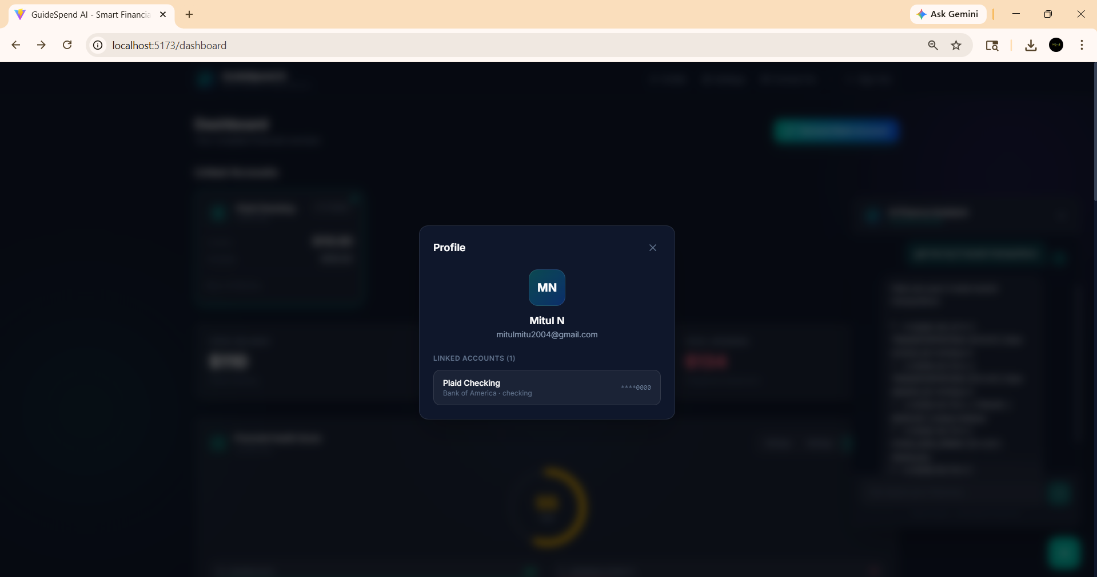

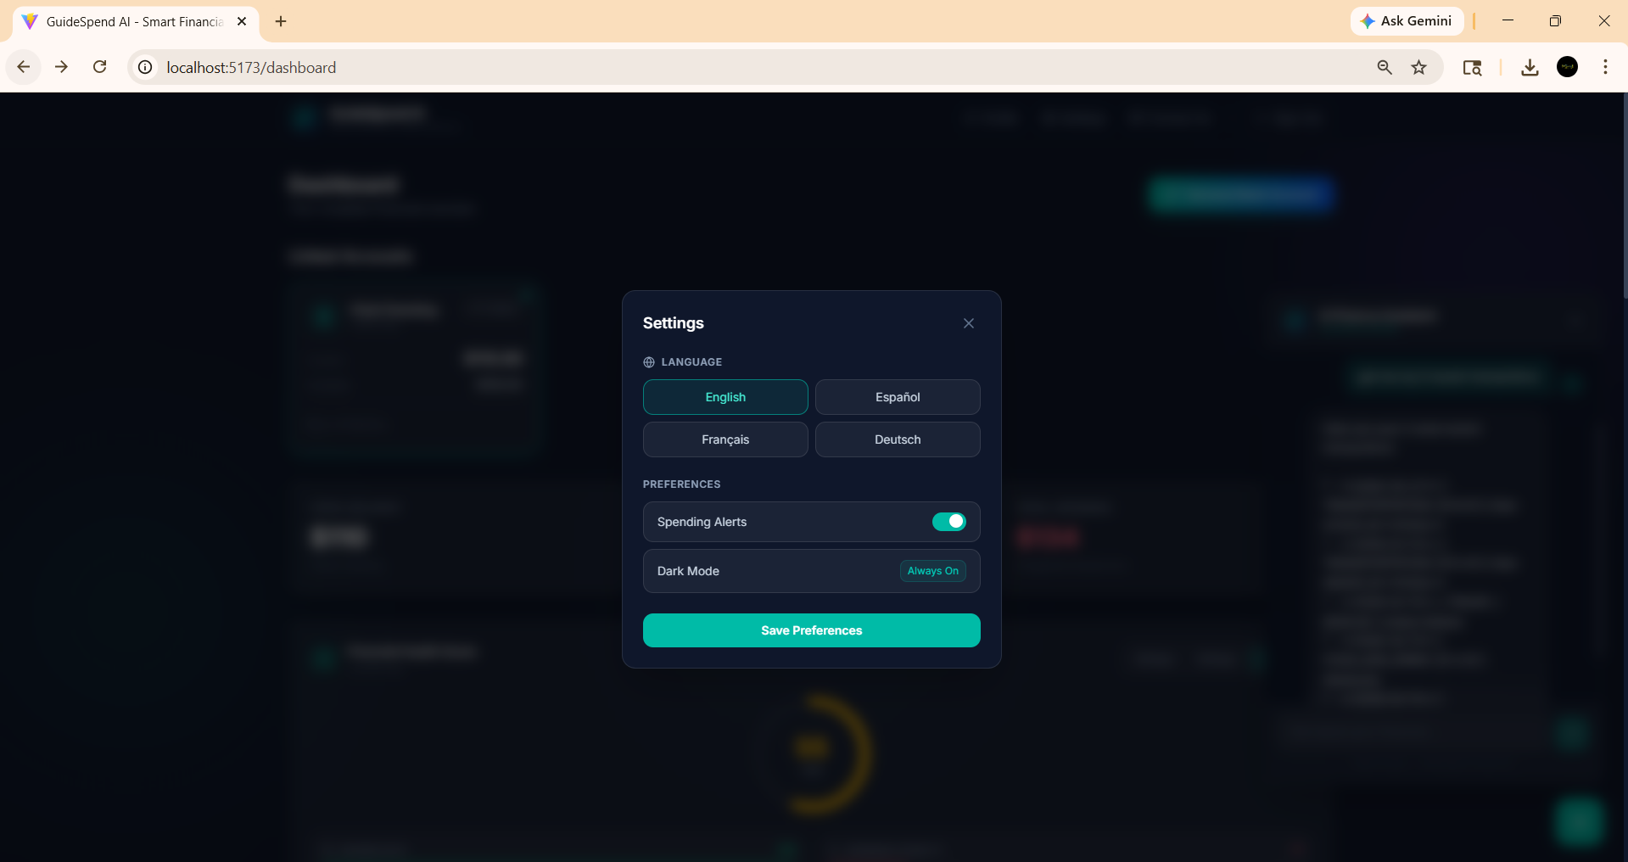

6.9 Logging Out
To log out of GuideSpend AI:
- Click the 'Sign Out' button in the navigation bar at the top of the dashboard
- You will be redirected to the login page
- Your session token will be cleared from the browser
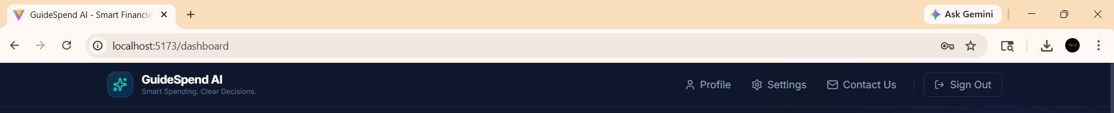

Glossary

7.1 Dashboard
The main screen of GuideSpend AI that displays all your financial information including account balances, spending analytics, and transaction history in one place.

7.2 JWT (JSON Web Token)
A secure token issued when you log in that identifies your session. It is stored in your browser and automatically attached to all requests to the server. If the token expires, you will be redirected to the login page.

7.3 Plaid and Sandbox Mode
A third-party financial data API that securely connects your bank accounts to GuideSpend AI. Plaid handles your bank credentials directly - GuideSpend AI never sees or stores your actual banking username or password.
A test environment provided by Plaid that simulates real bank account connections using test credentials. No real banking transactions are involved. Used in the current version of GuideSpend AI for demonstration purposes.

7.4 Gemini API
Google's large language model (AI) service that powers the GuideSpend AI chatbot. It analyzes your transaction data and generates natural language responses to your financial questions.

7.5 Transaction
A record of a financial activity such as a purchase, payment, or deposit. Transactions are synced automatically from your linked bank account via Plaid.6

SSL (Secure Sockets Layer)
An encryption protocol that protects data transmitted between your browser and the GuideSpend AI servers, and between the servers and the database.
7.7 Fernet Encryption:
A symmetric encryption method used by GuideSpend AI to securely store Plaid access tokens in the database. Encrypted tokens cannot be read without the corresponding encryption key.

